|  |  |
| --- | --- |
| Canon EOS 90DCanon EOS 90D (Nhập khẩu,+ Lens 18-135mm f/3.5 - f/5.6 IS USM) Canon EOS 90D + 18-135mm Canon EOS 90D + 18-135mm 2 Canon EOS 90D + 18-55mm 2 Canon EOS 90D + 18-55mm 8 | **Featured information:**  Sensor: APS-C  ISO range: 100 - 25600 (expandable 100 - 51200)  Resolution: 32.5MP  Wireless connection: WiFi  Price : $ 1600  **Specifications:**  Anti-Vibration  Digital (Video Only)  Lens Mount  Canon EF-S  Sensor Format  APS-C (1.6x Crop Factor)  Resolution  34.4 Megapixels  Size photo  6960 x 4640 |

**Overview:**

Canon EOS 90D is considered a mid-range DSLR camera for those who want to improve their photography abilities. The camera has dimensions of 140.7 x 104.8 x 76.8 mm and weight of 701g and is designed with a 3.1 inch flip screen. This Canon camera is dust and moisture resistant, suitable for use when taking photos in many different weather conditions. Besides, the buttons are placed in convenient positions to help users be flexible during use.

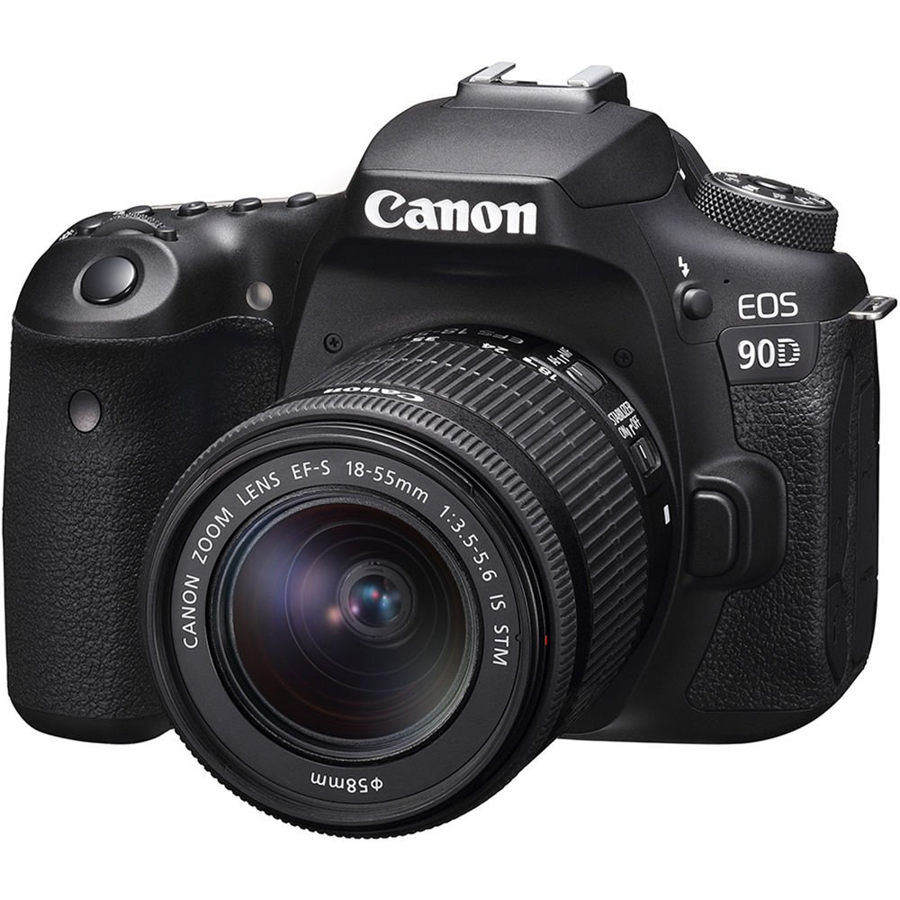

The camera is equipped with a high-resolution 32.5MP APS-C format sensor that creates impressive photos. ISO sensitivity from 100-25,600 (expandable to 51,200) allows the camera to shoot in low light conditions with good noise reduction. In addition, the DIGIC 8 image processor is also incorporated in the camera, providing excellent image quality with high sharpness. In particular, this image processor also helps improve the ability to record UHD 4K 30p video.

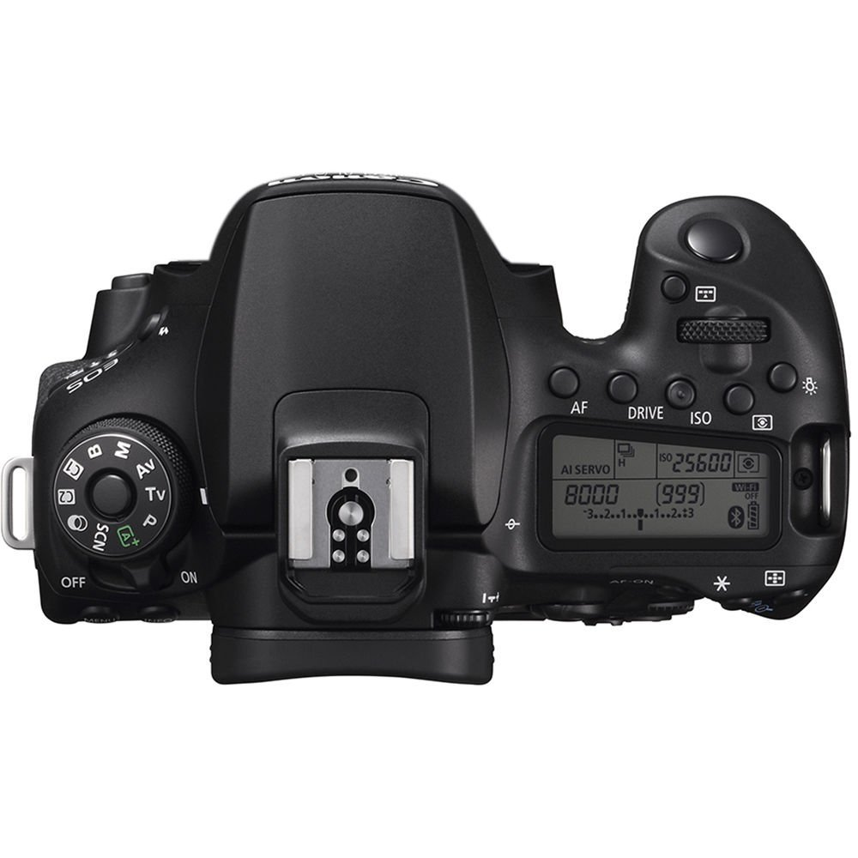 Canon EOS 90D can connect to smartphones via Bluetooth and Wifi. This feature allows you to easily share images/videos via your smartphone via the Canon Camera Connect app. In particular, you can adjust settings and change shooting modes on the camera through this application.



Equipped with the Dual Pixel CMOS AF focusing system, the Canon EOS 90D provides fast, accurate focusing. With 45 focus points through the viewfinder combined with the Spot AF focus feature, focusing is smoother and 2.5 times more accurate than normal. In addition, the camera is also equipped with a Touch AF feature that allows users to focus directly by touching the screen. With this feature, you can easily focus on subjects to your liking.